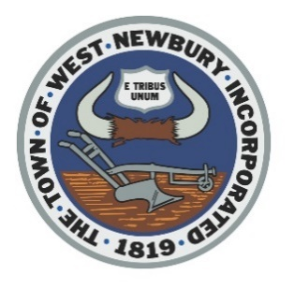
TOWN OF WEST NEWBURY

BOARD OF HEALTH

TOWN OFFICE BUILDING PHONE 978-363-1100
381 MAIN STREET, WEST NEWBURY, MA 01985 FAX: 978-363-1119

Combined Sewer Overflow (CSO) Update 6/27/22

In January 2021, Governor Baker signed An Act Promoting Awareness of Sewage in Public Waters into law. This new law will require the public to be notified when there is untreated wastewater being discharged to waters of Massachusetts through Combined Sewer Overflows (CSO) events. The law can be viewed at https://malegislature.gov/Laws/SessionLaws/Acts/2020/Chapter322. The requirement of public notification takes effect on July 6, 2022. You may receive Code Red messages when there are CSO events. These usually are associated with times of heavy rain, but can also occur due to high flows or heavy snow melt. If a CSO events occurs, then it is recommended that the public avoid contact with affected water bodies for at least 48 hours after a sewage discharge or overflow, and during rainstorms and for 48 hours after rainstorms end, due to increased health risks from bacteria or other pollutants associated with urban stormwater runoff and discharges of untreated or partially treated wastewater.

Residents can subscribe to receive CSO events by visiting the following links.

City of Haverhill CSO Notification Page
https://www.cityofhaverhill.com/departments/public_works_department/water_wastewater/wastewater/wastewater_collection_system/cso_public_notification.php

Greater Lawrence Sanitary Control District CSO Notification Page
http://www.glsd.org/combined-sewer-overflow-2/

City of Lowell CSO Notification Page
https://www.lowellma.gov/1287/CSO-Notifications

If you have any questions, feel free to send an email to psevigny@wnewbury.org or visit our CSO tab on the Board of Health’s web page. https://www.wnewbury.org/board-health

