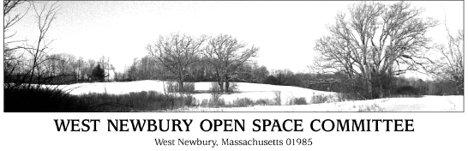

Meeting Agenda

Wednesday May 22, 2019
7:00 pm
Second Floor Meeting Room
Town Office Building

- Minutes

- Trails: Maintenance, Stewardship, River Hill Update, Crane WMA trails inquiry, CPA Funding for trails, All Access Trail discussion with Mill Pond

- LAND Grant deadline July 11, 2019.

- Greenbelt Fundraising Efforts for BSF and River Road and OSC Participation. Volunteers needed for Memorial Day Parade and Carrying/Supporting Greenbelt Banner

- 22 Church Street Public Hearing continued to May 22 at Planning Board

- Summer Bicentennial Walks June 20 and 22. Carol Decker to lead.

- Goals and Objectives

The Committee reserves the right to take agenda items out of order.

