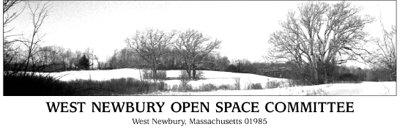

Meeting Agenda

Wednesday June 19, 2019
7:30pm
Second Floor Meeting Room
Town Office Building

- Minutes

- Membership

- Trails: Maintenance, Stewardship, River Hill Update, Permitting, Grant Funding for Trails, All Access Trail discussion with Mill Pond, Americorps, Invasives

- OSC Participation in Municipal Vulnerability Program

- Update BSF and River Road

- Summer Bicentennial Walks June 20 and 22. Carol Decker to lead.

- Strategy for Action Plan

The Committee reserves the right to take agenda items out of order.

