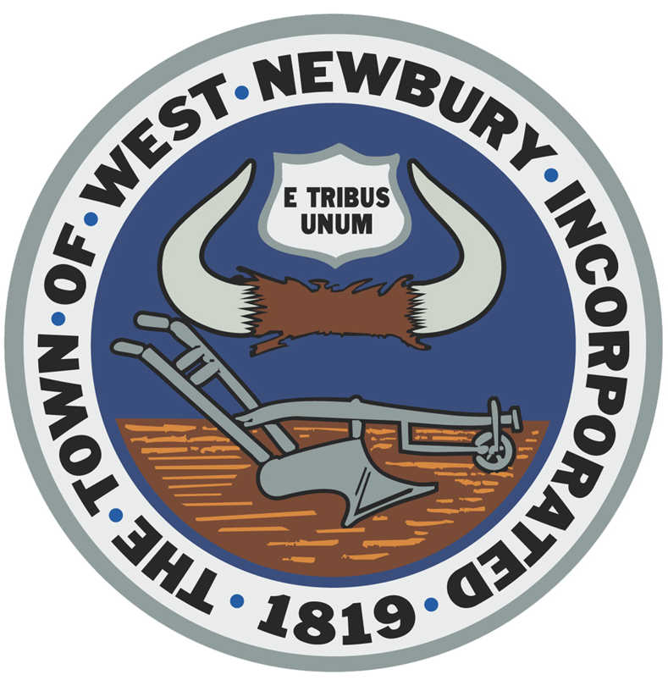 TOWN OF WEST NEWBURY
CONSERVATION COMMISSION
381 Main Street, West Newbury, Mass. 01985
TEL: 978-363-1100 x126 FAX: 978-363-1119

West Newbury Conservation Commission Agenda

Monday, March 5, 2018

Meeting begins at 7:30pm.

Cont. Public Hearing --- Notice of Intent --- Cottage Advisors for Drakes Landing, 365 Main St. (DEP# 78-679) --- The applicant would like to construct an open space development with the roadway intruding into the buffer zone and bordering vegetated wetland.

Cont. Public Hearing --- Abbreviated Notice of Resource Area Delineation ---ANRAD --- Fredrick and Stefanie Hufnagel for River Rd. (Map R-24, Lot 24-5 and 24-7) (DEP# 78-682). --- For the delineation of resource areas.

Cont. Public Hearing --- Notice of Intent ---William Cranley and David Mignault, 119 River Rd. (DEP# 78-683). --- For a dock and concrete platform. The work proposed is within the Merrimack River resource area.

Cont. Public Hearing --- Notice of intent --- Riverworths, LLC for 11 Prospect St. --- Applicant would like to install a replacement septic system within the buffer zone to a bordering vegetated wetland.

Public Hearing --- Request for Determination of Applicability --- William Nally, 2 Woodcrest Drive --- For the paving of his driveway located in the buffer zone to a bordering vegetated wetland

Discussion: Pentucket School project

Discussion: Trails

Discussion: Minutes:

Other Business:

The next scheduled Con Com meeting Monday, March 19, 2018

